Final Report on the CityVan Rural Mobility Pilot

Dwight Mengel, Chief Transportation Planner, Tompkins County Dept of Social Services
4/9/2012, Revised 9/9/2019

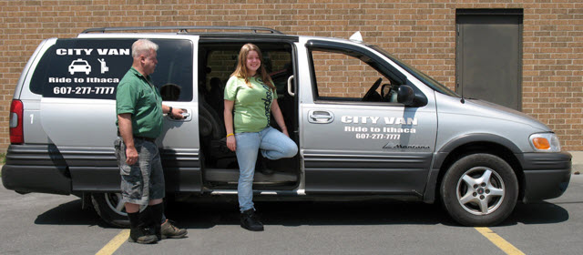

CityVan was transportation pilot project primarily funded with Federal Transit Administration JARC (Job Access and Reverse Commute) Program funds. JARC grant funds for CityVan were matched by DSS funds for Medicaid transportation, children services transportation and employment. Therefore, no local County funding was used for this project. The County contracted with Ithaca Dispatch to operate the CityVan Pilot Project in March 2010. The program pilot ended December 31, 2011. This report covers the entire operating period.

CityVan Pilot Goals
- To demonstrate a viable market for rural van service in Newfield and Enfield.
- To consolidate and reduce cost of Tompkins County Dept. of Social Services (DSS) transportation for Medicaid and Employment programs.
- To achieve productivity of 3 passengers per revenue hour.
- To achieve an average trip cost less than $19/trip, the price of a one-way taxi trip.

Operations Model
The Towns of Newfield and Enfield were selected for the pilot. They are adjacent to each other. Newfield’s population was 5,179 (2010). Enfield’s population was 3,512. Newfield has a large rural hamlet (Newfield) and large mobile home parks, providing locations of rural residential density. Enfield’s population is more dispersed. Both towns are served by public transit (TCAT), paratransit (Gadabout) and taxis.

Tompkins County contracted with Ithaca Dispatch, Inc. to operate CityVan. The concept was straightforward. Taxis operate in rural towns daily, with a majority of trips being for Medicaid Non-Emergency Medical Transportation (NEMT). CityVan enabled a subsidized, on-demand or pre-scheduled, shared-ride taxi service. A minivan was converted to CityVan use, so 5-6 people could be transported. Travel time was billed to the County in 15-minute increments, when a taxi carried CityVan passengers. Therefore, the County did not pay for time or mileage before picking up or after letting off CityVan passengers.

Passenger fares were $2.00 for trips within a town and $3.00 for trips between towns or to the City of Ithaca. The fare structure matched Gadabout’s fares for county paratransit service. CityVan was open to passengers 13 years and older. Children rode free with an adult.

The initial operational concept was to take rural residents to and from TCAT bus stops in the Towns. This required a degree coordination which could not be implemented at that time. So, CityVan took rural residents anywhere in the two towns and to the City of Ithaca. CityVan stopped on request along South Meadow Street and terminated at the TCAT Green Street bus stop. This enabled people, primarily employees, to get on and off on Route 13. Later, CityVan added a demand stop at the Ithaca High School to serve ICSD employees.

Ridership:
The total number of trips provided throughout the duration of the pilot was 5,363. The graph below shows the total ridership for each month. During the first nine months ridership steadily increased to a total of 1,528 trips. In 2011, ridership doubled to 3,835 with monthly ridership fluctuating between 260 and 375 trips per month. During the first nine months of operation total number of DSS subsidized trips (Employment and Medicaid) was 301. In 2011, the total number of DSS subsidized rides was only 190 with the decrease due to was a large drop off in the number of Medicaid rides resulting from changes in the program’s billing system.

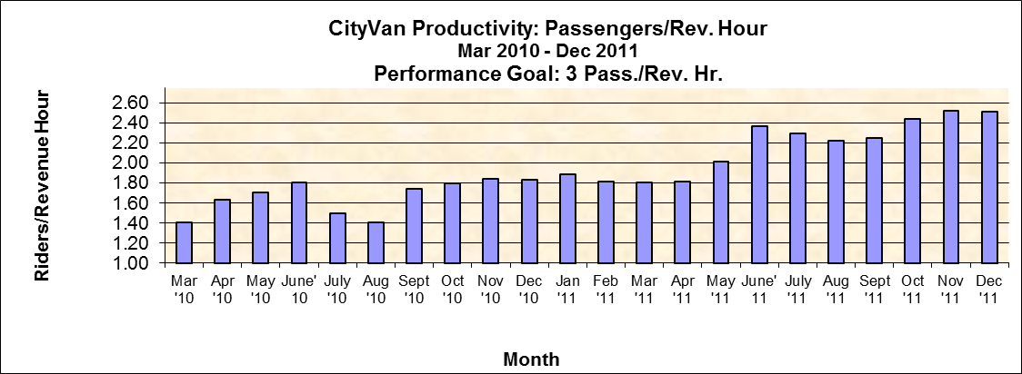
One CityVan goal was to carry an average of three passengers per revenue hour. The closest the service came to meeting this goal was in the last quarter of October June-December 2011 when productivity exceeded 2.4 passengers/revenue hour. In practice, this goal was beginning to be realized as ridership increased. While important, the productivity goal was less important than cost per passenger-trip goal.

Program Costs:
Program costs included initial start-up mobilization costs of $47, 667 paid during the first six months (May-Aug). Total operating costs were $117,395 over the entire period (May 2010-Dec 2011). The program generated revenue through fares which totaled $13,830. The chart below shows a detail of ridership, operating costs, revenues and cost per rider for May 2010 to Dec 2011. As discussed in Lessons Learned below, the operating price of CityVan was cut from $60/hour to $40/hour by changing insurance. This reduction saved the pilot project. By November 2010, the program achieved Goal #4 with an average cost per trip of $18.87. By the end of the pilot the average cost per trip dropped to $13.

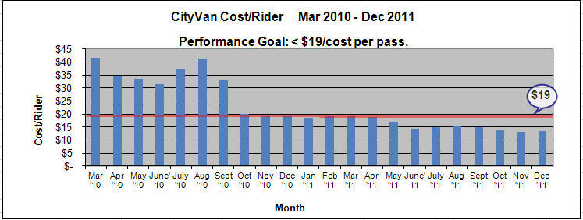

Lessons Learned:

- Cutting the insurance expense in September 2010 was the key action contributing to the project’s success. Ithaca Dispatch, Inc. changed insurance insurance coverage from taxi insurance to livery insurance. Afterwards, their price to operate CityVan was cut from $60 to $40 per revenue hour. The price decrease gave CityVan enough time to increase ridership productivity to beat the $19 cost per passenger target. If CityVan’s expenses could not have been sharply reduced in October 2010, the pilot would have ended early.

- Building ridership for a new service takes time and sustained effort. The best advertising is person to person by word of mouth. While we advertised in appropriate “rural Pennysaver” papers and on the radio, the County’s efforts at grassroots outreach slowly and steadily increased ridership. We maintained a CityVan website (cityvan.weebly.com), made several mass mailings to DSS clients, and distributed CityVan information through the towns, churches, senior housing, at community markets and events, libraries, schools and via 211/Tompkins and Way2Go. One note, at Harvest Festivals and other events we held a raffle for five CityVan day passes. I decided we should award passes to all raffle participants as it was better to have 30-40 people telling their friends about CityVan than just five winners.

- We did not analyze location data of origins and destinations of passenger-trips. The taxi drivers told us many riders were picked up in more remote locations of the towns. CityVan was the first test of on-demand rural ride service. By increasing our productivity and our marginal taxi rental costing $10 per 15 minutes, the service was as cost effective as we could provide in 2010-11.

- A future effort to expand the CityVan concept to rural towns in the County would require taxi companies to computerize their trip planning and billing. We need to simplify billing for the County and to use routine customer travel information to better understand the submarkets being served. Going to work emerged as the major trip purpose served by CityVan. In our exit interviews with CityVan users, a number said they would relocate closer to TCAT bus routes to enable them to commute to work. However, people with non-traditional work schedules would need to rideshare, a less reliable services than provided by CityVan.

- More information is at www.cityvan.weebly.com or contact Dwight Mengel, 607-274-5605, dwight.mengel@dfa.state.ny.us.

Addendum 1. CityVan Photos & Marketing Materials

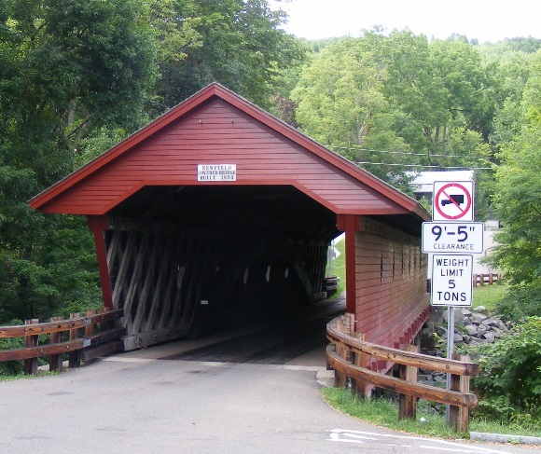
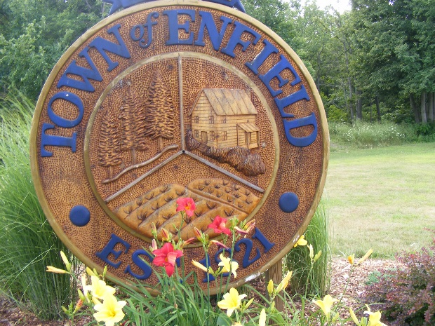

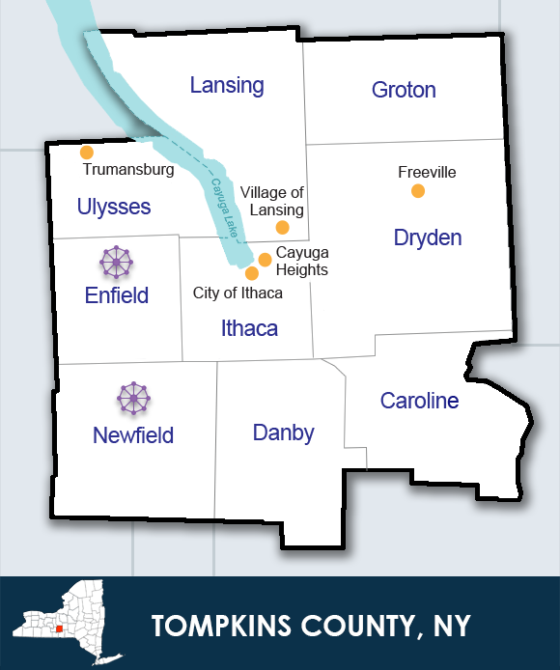
Figure 1. Enfield & Newfield in Tompkins County

Figure 2. Newfield Covered Bridge
Figure 3. Town of Enfield Sign

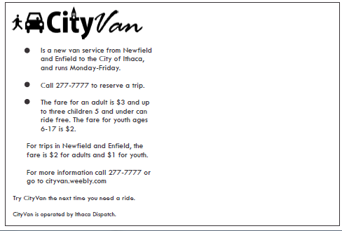
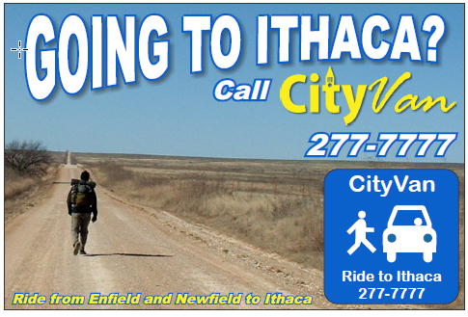
Figure 4. CityVan Postcard side A
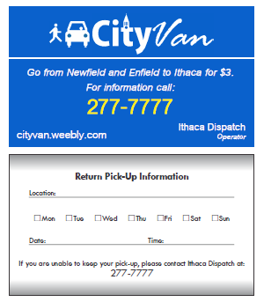
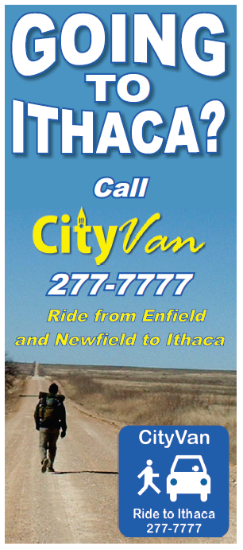
Figure 5. CityVan Business Card
Figure 6. CityVan Rack Card

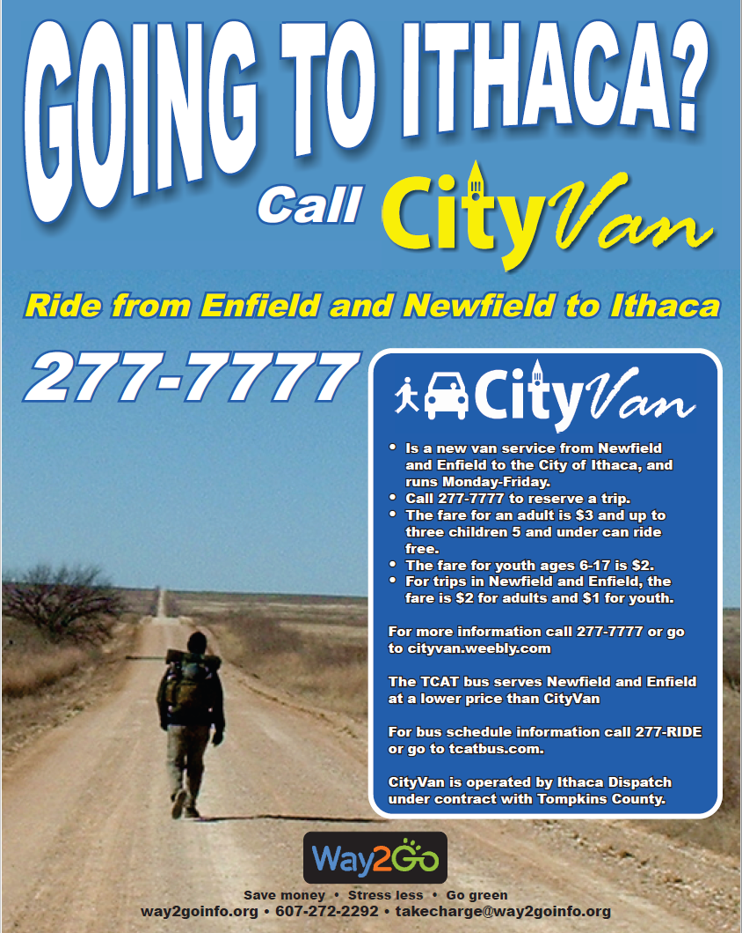
Figure 7. CityVan Poster

